

VERTICAL DIFFUSION PM PROCEDURE (QPM)
PM Type: QPM Prepared By: Michael,卡莫那Department: S200 Furnace Date: May 2020
VL-800 introduction and functions.
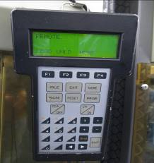
F1 to F4: screen menu selection.
Idle: Main menu display.
Exit: To return to previous selection or page.
More: Extend selection page.
Pause: To temporarily stop the action.
Reset: To refresh alarm.
Page: To go to next page.
CCW/off: counter clock wise motor function.
CW/on: clock wise motor function.
ENT: to confirm action.
M01 to M06 Introduction and functions.
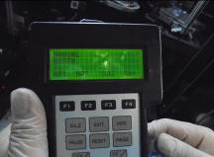
M01: Boat elevator motion UP/Down.
M02: Boat arm swing/rotate (P01, P02, P03).
M03: Door shutter motion UP/Down.
M04: Door shutter swing motion (Open/Close).
M05: Boat lock free (boat lock/Unlock). Motion Up/Down.
M06: Boat Elevator rotation 360 degrees. (CCW/CW).

Robotic arm Introduction and functions
- Robotic arm parts.
- Boat holder quarts – Position below the boat to level the boat to robotic arm, Ideal gap (3mm).
- Stopper – To hold the boat in place to the robotic arm, Ideal gap (0.5 mm to 1 mm)
- Positioning quarts – To support and balance the boat position to the arm, Ideal gap (2mm).
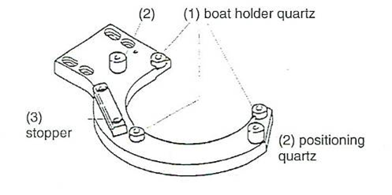

- Robotic arm orientation to boat.
- Use VL-800 to control movements of arm from position P1,P2,P3.
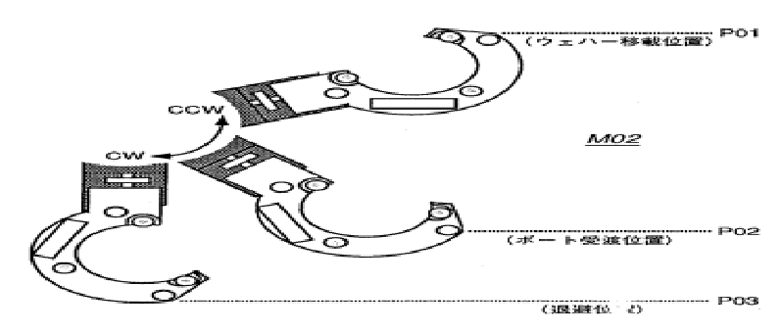

- How to check boat to robotic arm and pedestal?
1. Use VL-800 and select M05 to unlock the boat, then select M01 go to positon 1 or P1, Then select M02 + CW to position 2 or P2, and then go to M01 + CW position 2 or P2.
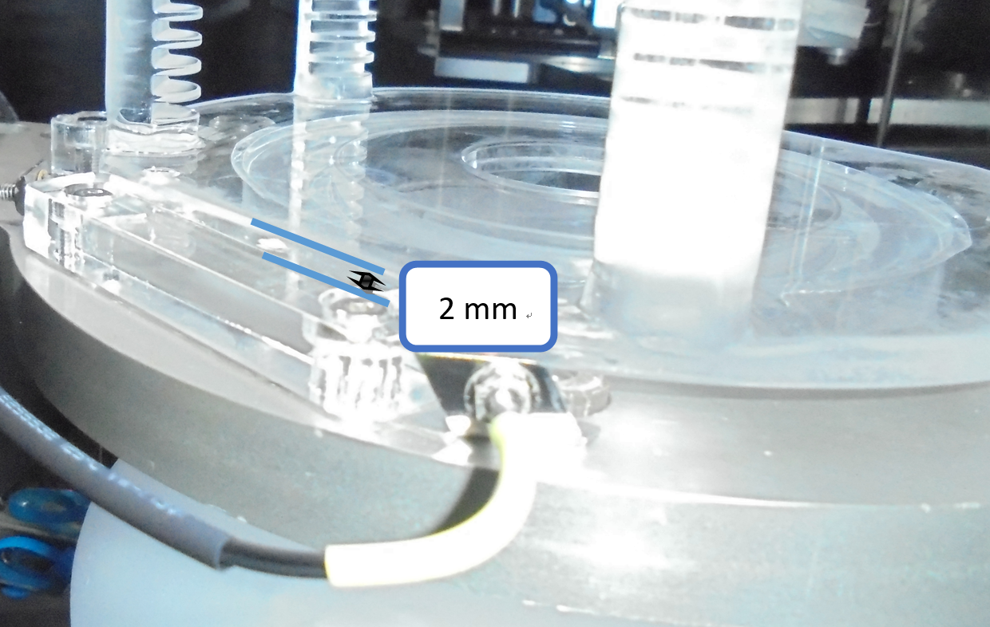
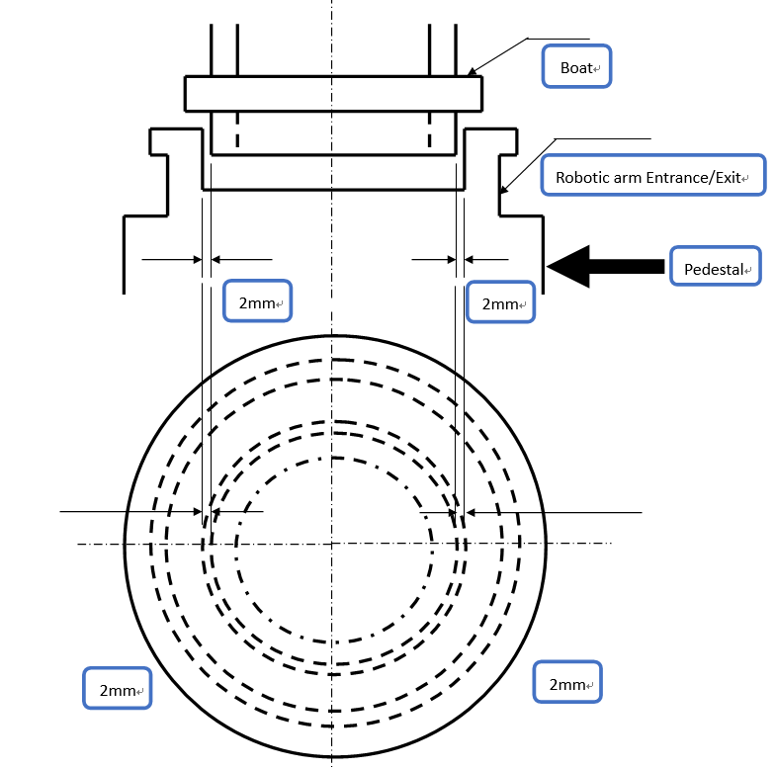

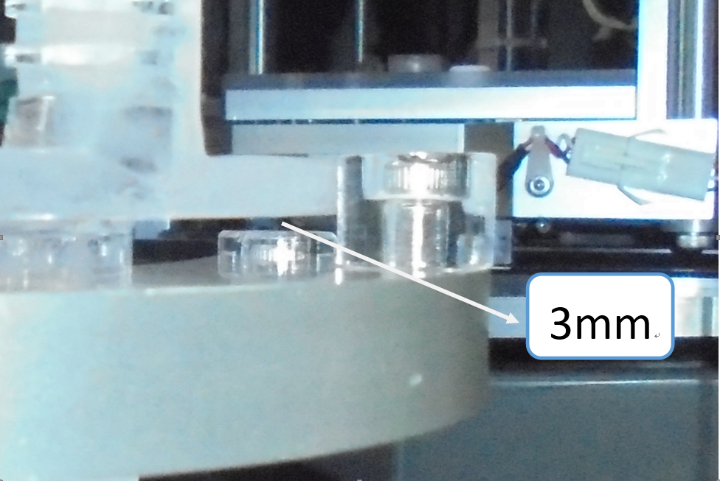

T-Bawl Introduction for transfer check.
- F1 Initialize (robot assembly, carrier, roller).
Example. select (F1), initialize sequence start? Select “Y “or Yes (Enter)
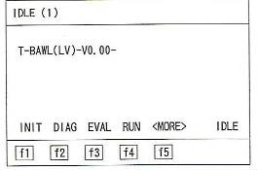

- F3 EVAL or evaluation process.
Example. Select (F3), 01 carrier load (ENTER), Input Carrier NO. C1 (ENTER) + F1 to start. Repeat action for C2 – C6 and C8.
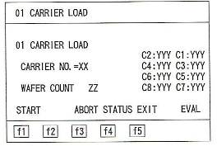
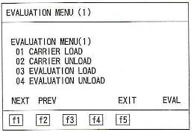

3. F3 EVAL or evaluation process. (Transfer Check Wafer)
Example. Select (F3), Select (F1) for next page, 05 Wafer transfer (ENTER),
Input data for “ SEQ.=FORK -5 LOAD or FORK -1 LOAD” , “ CARRIER NO=C1 or C2,C3,C4,C5,C6,C8” , ” CARRIER PITCH=01-05, 06-10, 11-15, 16-20, 21-25” , ”BOAT PITCH= 16” Is as you desired location of the boat to transfer wafer, Press (ENTER) to confirm action.
All input data will be input by keyboard install or touch pad in the machine.
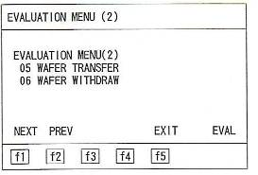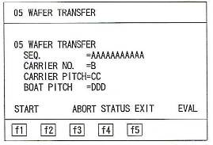

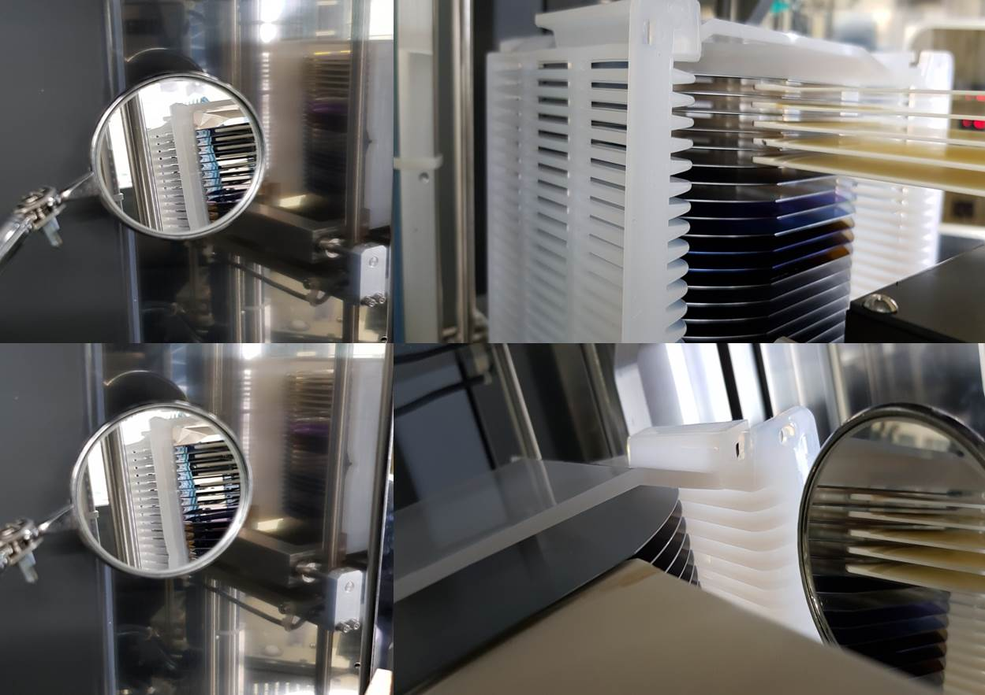
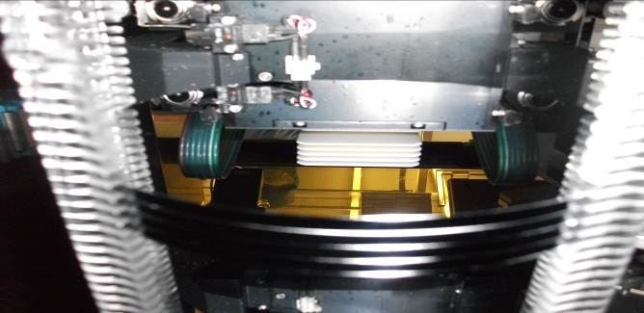

Cassette
Boat

PM Items to prepare.
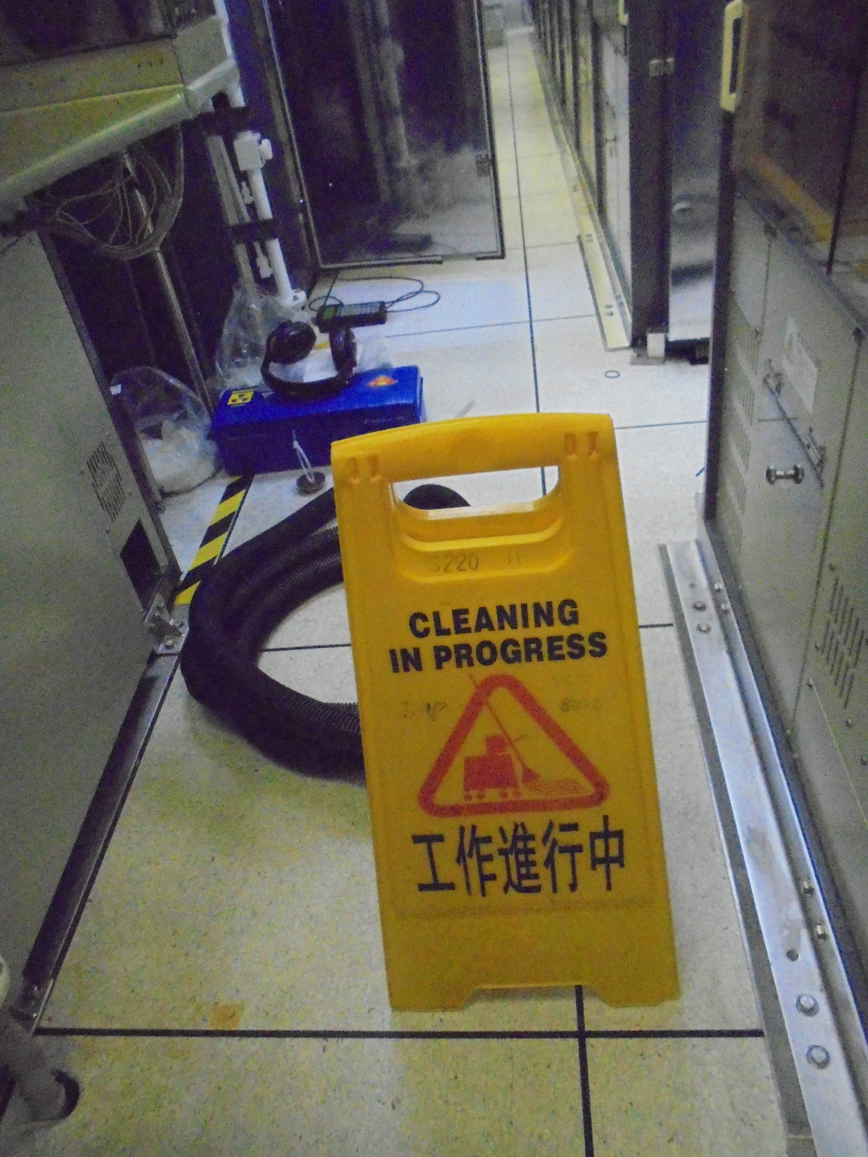
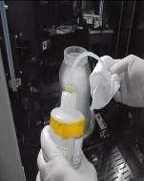
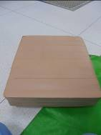
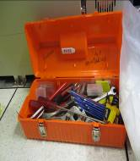

Sign and vacuum
IPA, Wipes, and trash bag
Knee Guard
Tools

Q
QPM Procedure
Step 1. Check QPM schedule. | Step 2. Check Machine Status.  Note: No wafer, dummy and cassette. Put sign.
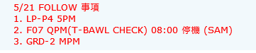 | 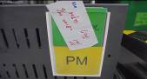  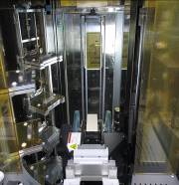  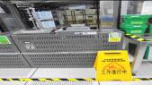

Step 3. Remove Machine cover. | Step 4. Load Cassette from C1 to C8 except C7 and check for loading abnormality.
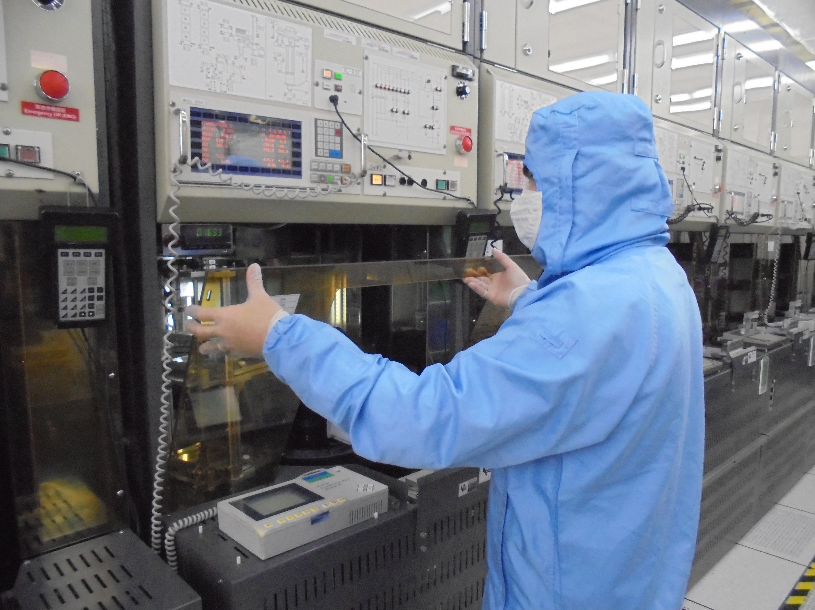 | 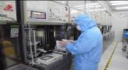  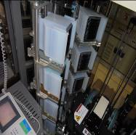  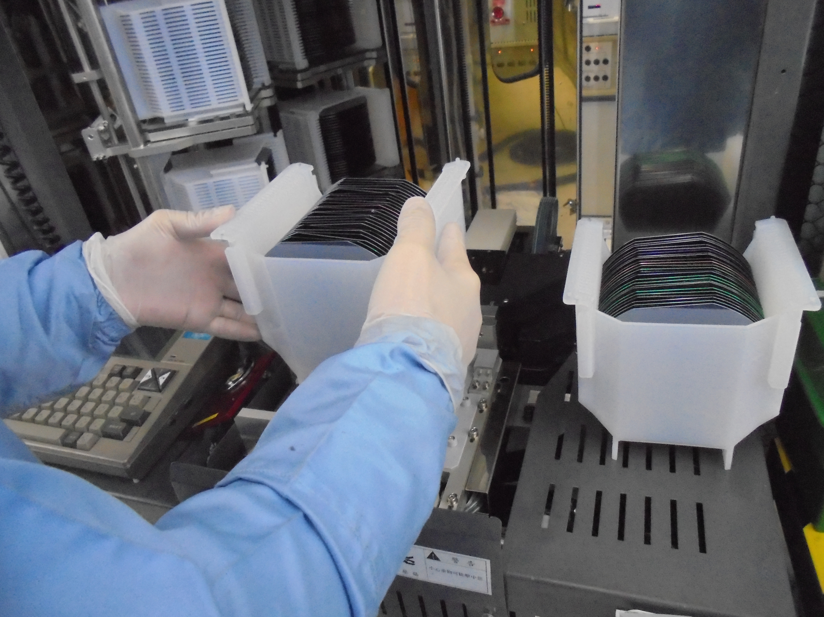

Step 5. Check boat condition for High temp. boat.  Note: Put wafer in the middle. | 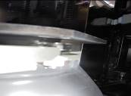  Step 6. Check boat to pedestal alignment.  Note: Center the pedestal and boat by 2mm all side
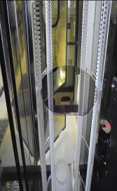  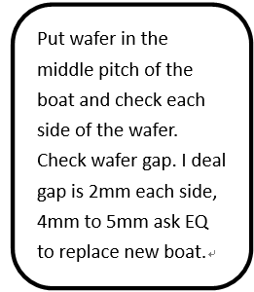  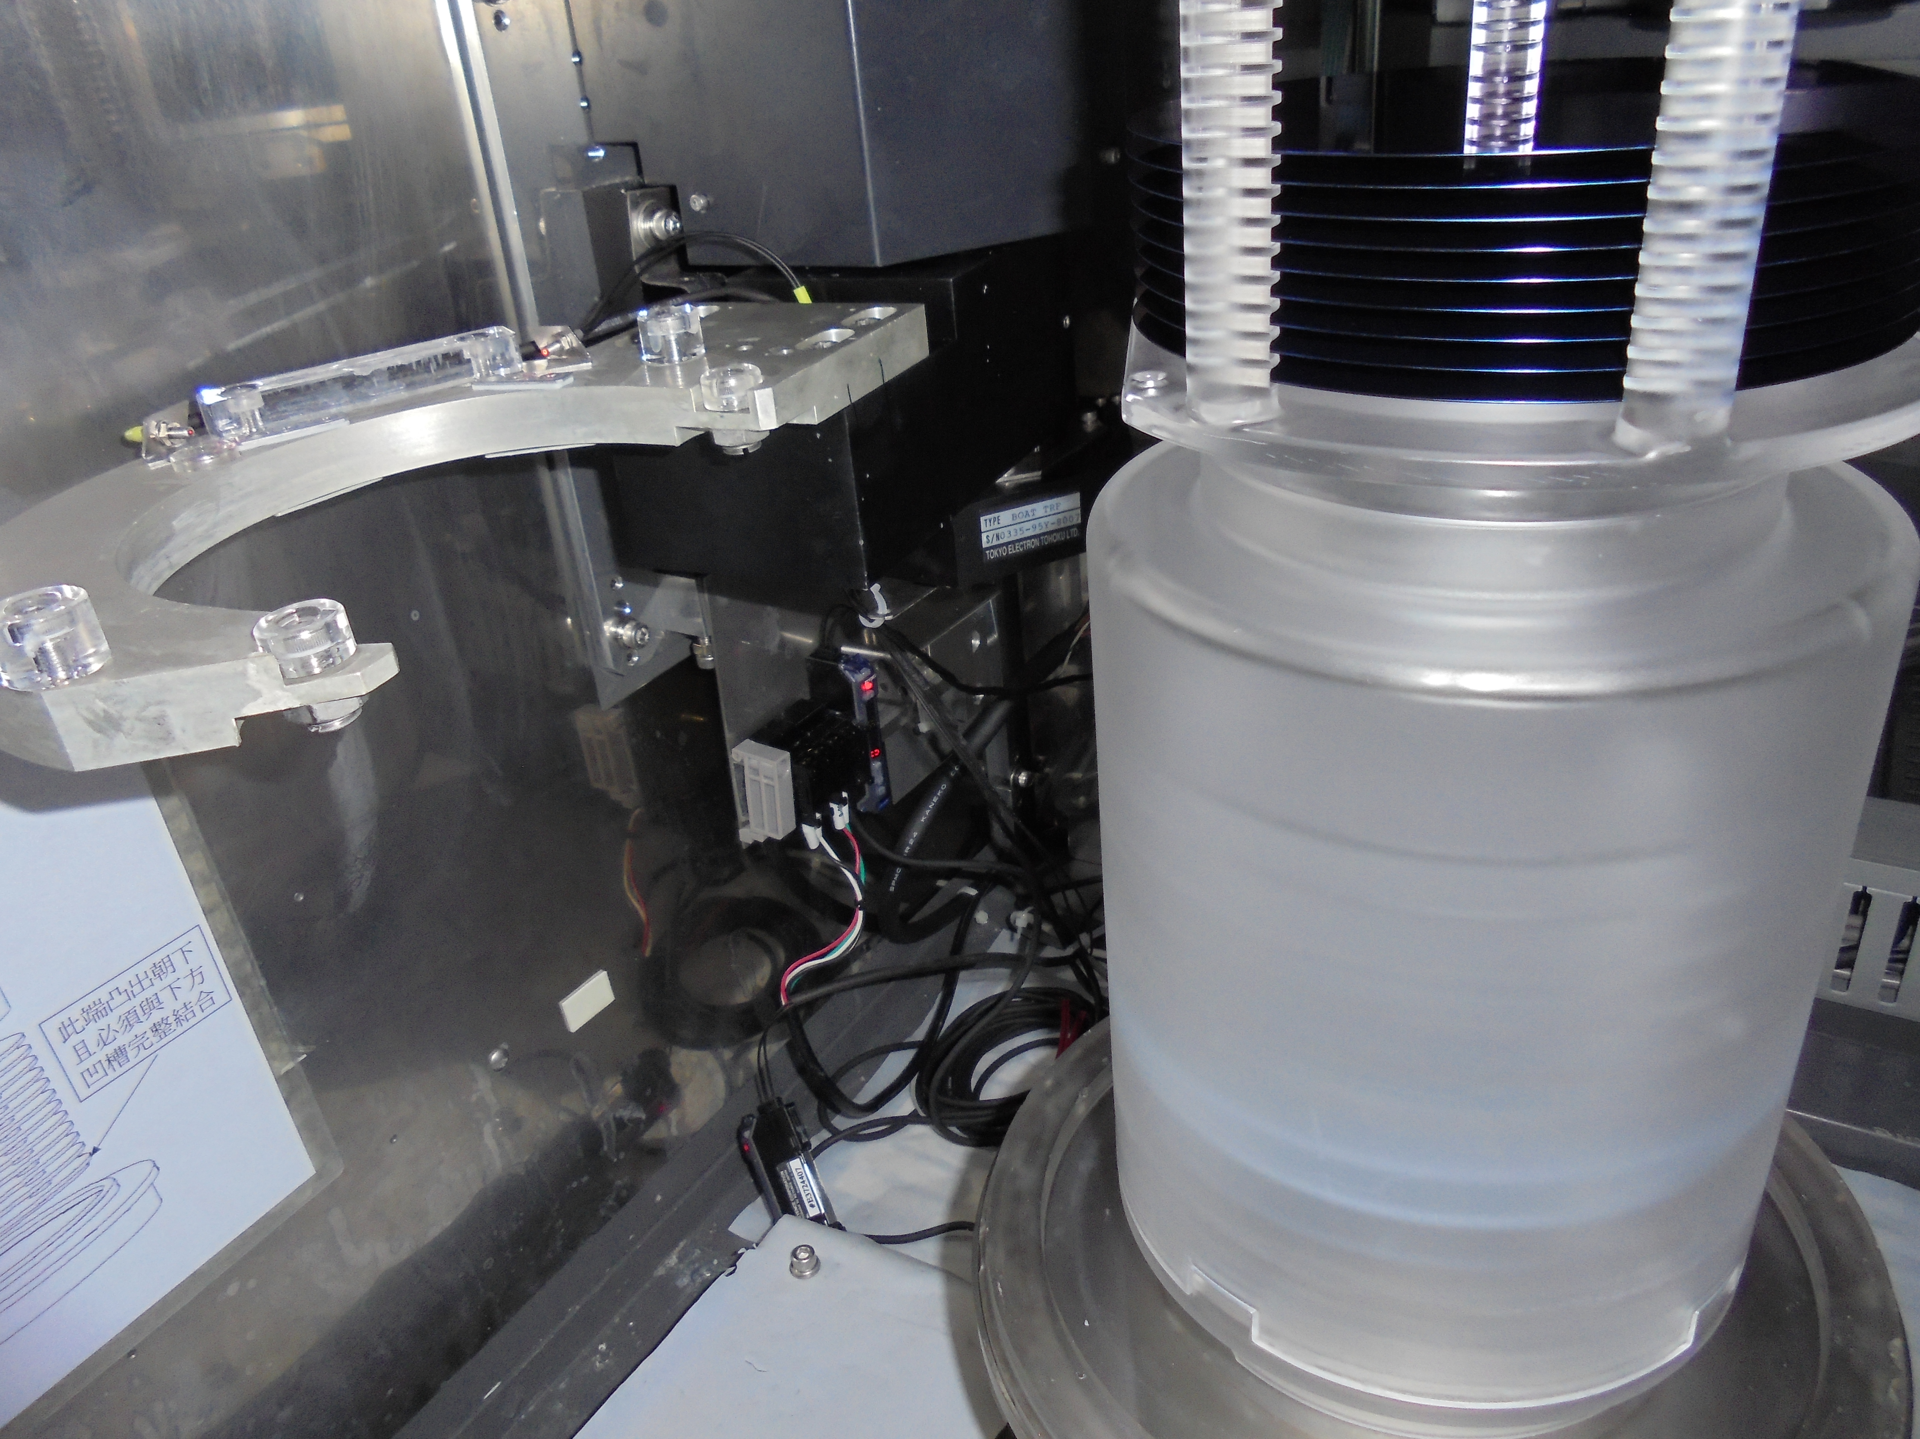 | 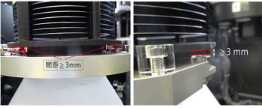

Step 7. Adjust 2 points of M02 if necessary to avoid vibration and shaking. | Step 8. Check boat to tube gap.
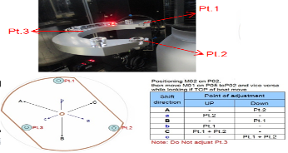 | - Open door shutter M03.  - Open door shutter M04.  - Boat up by M01 for 1000 steps.  - Rotate boat M06 for 360 degrees to P01.  - Wait for the boat to cool down.

Step 9. Check boat lock. Boat lock should be center. | Step 10. Transfer check.
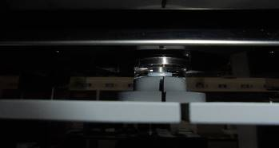  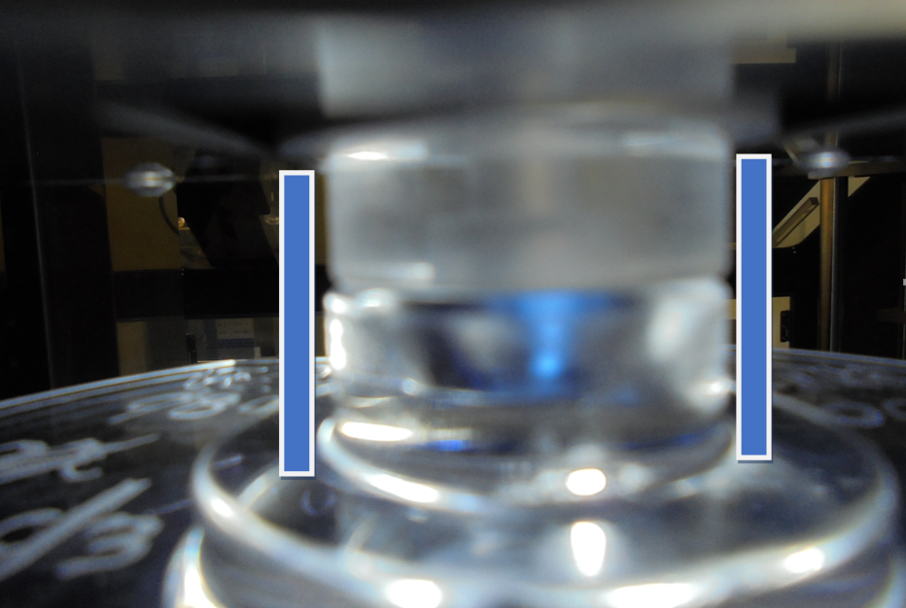 | 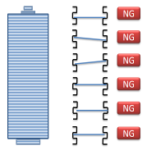  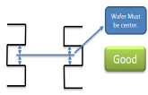

Step 10.1. Transfer check. Wafer transfer pitch. | Step 10.2. Transfer check. Wafer to fork gap.
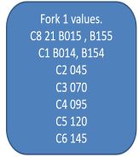  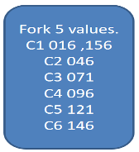 | 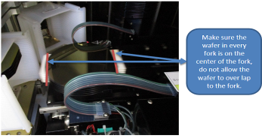

Step 10.3. Fork to wafer gap. Use Mirror to see. | Step 10.4. Transfer check. Wafer to boat gap.
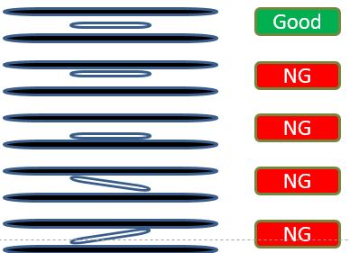  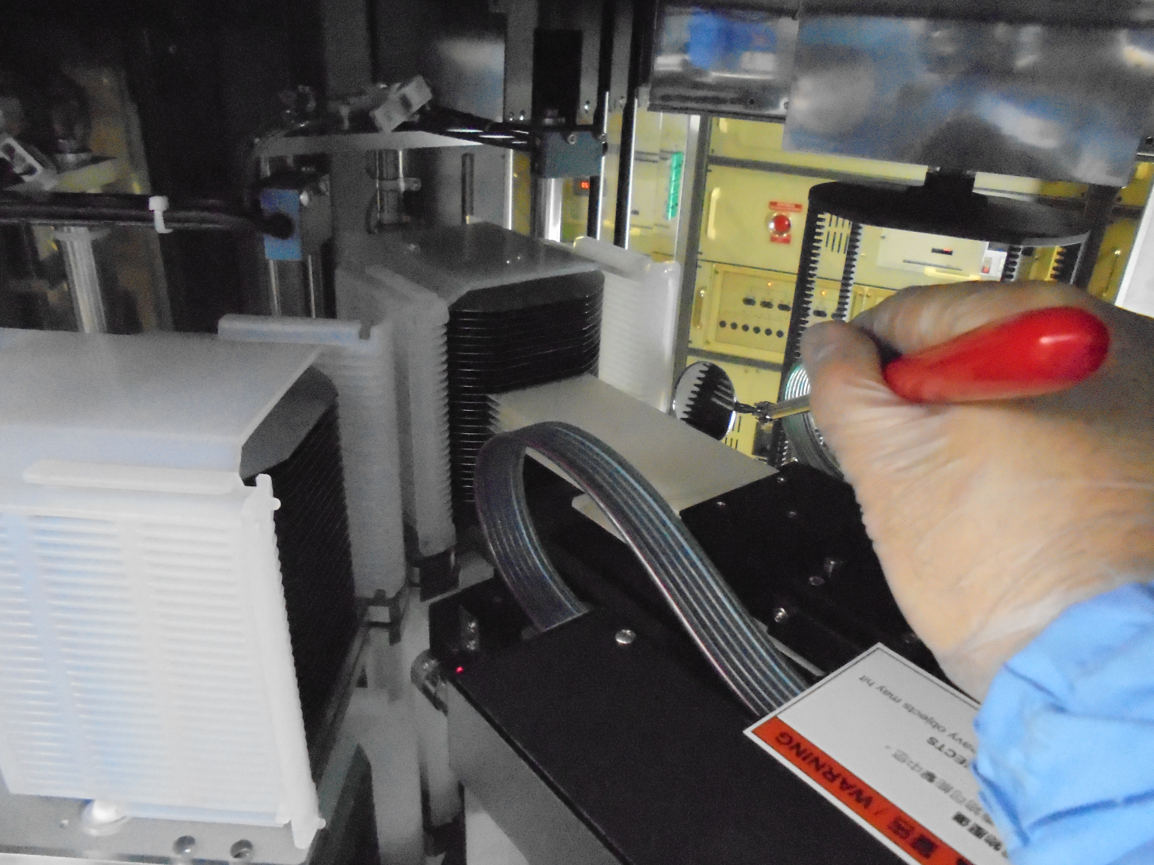 | Note: Check 4 points of the boat from the wafer. Ideal Gap is 0.5mm to 2mm.

Step 11. Unload all wafer. | Step 12. Unload all cassette.
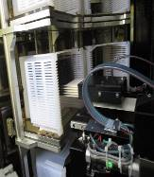  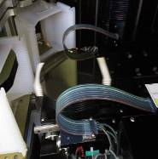 | Unload cassette from C8 to C1.

Step 13. Clean roller. | Step 14. Clean Stage and robot assembly.
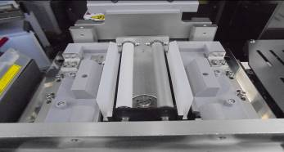 | 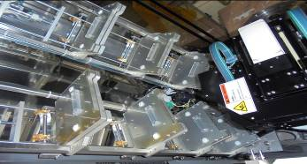
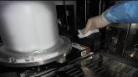
Step 15. Clean pedestal. | Step 16. Clean cover
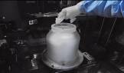  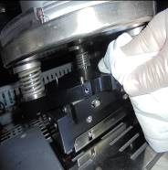 | 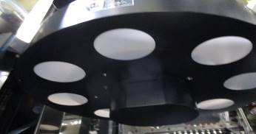

Step 17. Clean Machine and wipe it with IPA. | Step 18. Clean PM area and install cover.
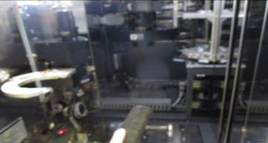
2mm
2mm

